Or Livne - 203972922

Daniel Levi - 203972922

1. **תמונה שמכילה טקסט

   התיאור נוצר באופן אוטומטיEigen decomposition:**

* Disproving:

|  |  |  |  |
| --- | --- | --- | --- |
| 1 | 0 | … | 0 |
| 0 | 2 | … | 0 |
|  | … | … |  |
| 0 | 0 | … | 3 |

**2. PCA:**

**2.1.1)**

**2.1.2)**

**2.1.3)**

* 1. **Prove or disprove:**

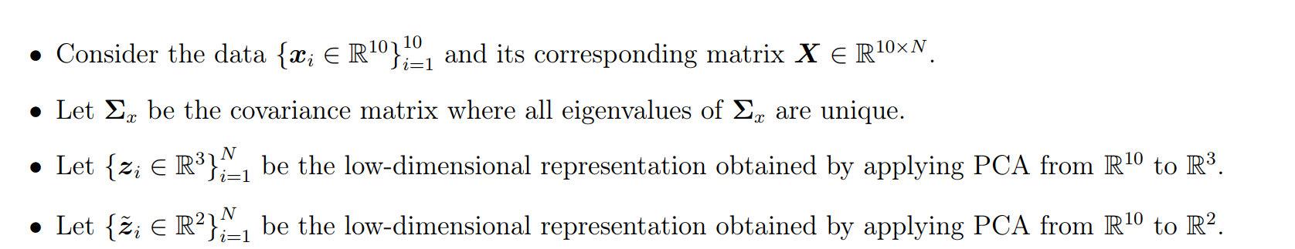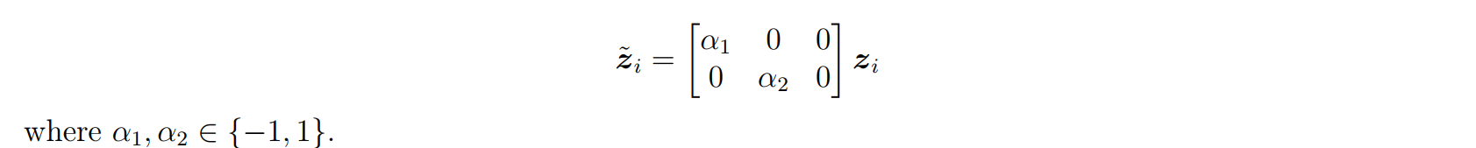

* **Ddddd**
  1. **תמונה שמכילה טקסט

     התיאור נוצר באופן אוטומטיGeometric PCA**
* Let be a fully ranked matrix (with )
* Since U is fully ranked, we can use the compact SVD decomposition and denote , where , .
* A, B are orthogonal matrices and diagonal matrix.
* Next will use compact SVD using the top d eigenvalue and eigenvectors.
* is semi-orthogonal ()
* by assigning we show that exist invertible matrix M
  1. Prove that both problems have the same optimal solution

* To prove that the optimization problem has the same optimal solution, we will start with the first optimization - **Reconstruction error minimization**
* Notice that
* So, we show the 2 optimizations are has the same optimal results
  1. **PCA analysis**

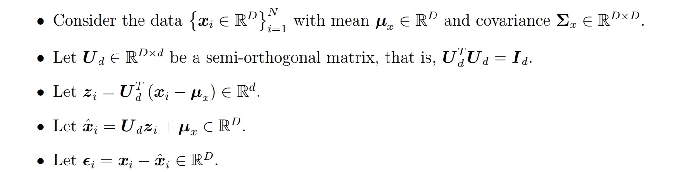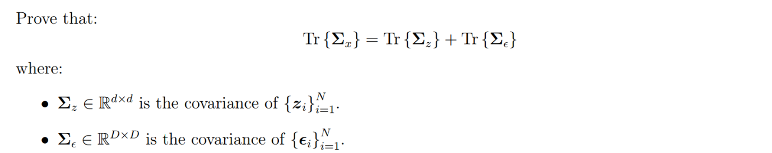

* Let's denote
* is matrix of errors, where
* we will show that
* notice that
* in Ex 2.4 we know that:
  1. 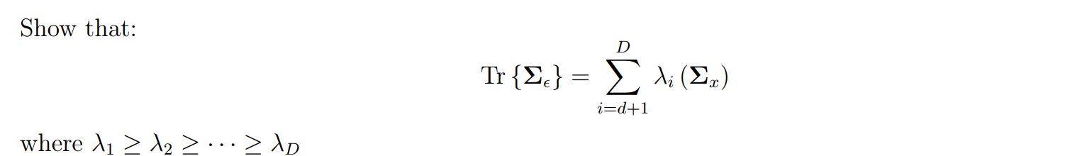prove
* Let's assume that be the top d eigenvalues corresponding to the d largest eigenvalues of
* We needed to show that
* We know that:

* Let's define:

* We know that:
* From 2.5 we know that:
* By combing all we know we can say that:
  1. **High-dimensional data PCA**

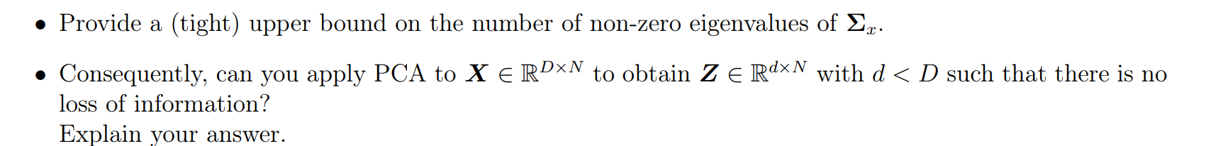

* Provide a (tight) upper bound
  + Notice that the number of # of is bound by the matrix rank
    - Rank(X)<= N 🡪 N is the tight upper bound
* can you apply PCA, and no loss of information?
  + The top d eigenvectors of are the same as the top left singular vectors of X, hence if d>=N, we will not loss any information.
  1. תמונה שמכילה טקסט

     התיאור נוצר באופן אוטומטי**Rank minimization**

* Notice that because rank(M) = d, hence d, and therefore we have two matrices B, with ranks d such that M = BC
* The following is equivalent to PCA problem which we saw 🡪 the optimal solution is for:
  + , THE SVD decomposition

1. תמונה שמכילה טקסט

   התיאור נוצר באופן אוטומטיKPCA

3.2) **Kernel matrix**

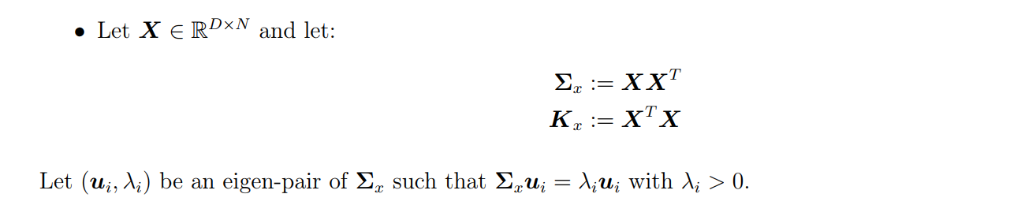

* Let:
* We know that 🡪
* By multiply both side by
  + Let's mark =
* is eigenvalue of , who corresponding eigenvector is

3.3) **Kernel functions**

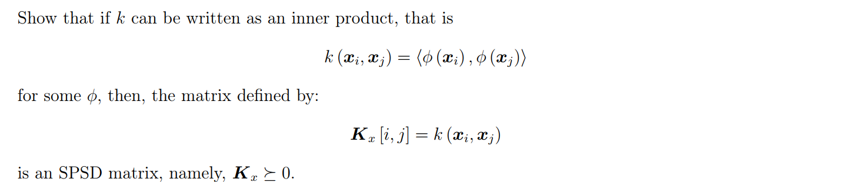

* First, we will show that every matrix multiplication in the shape of is SPSD
* To show that something is SPSD, needed to show that:
  + In our case M =
* Next, we will show that
  + Let be a matrix of applications of on every instance x 🡪
* Which means that every element in
* Therefore 🡪 K is SPSD
* 3.4) Prove or disprove:

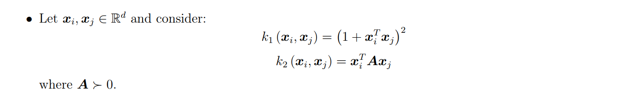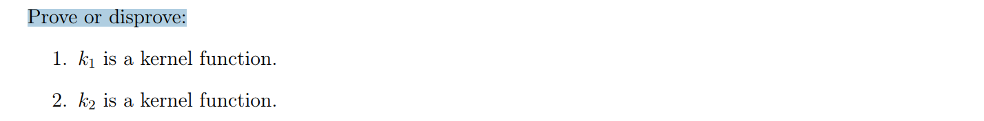

* K1
  + We will prove that
  + Let's show that

=

* K2
  + Since A is SPD we will use the EVD composition 🡪 , where:
  + Let's show that